JavaTM 2 Enterprise Edition

XML API for JavaTM Transactions

JSR 156

Specification Lead:
Mark Little
Hewlett-Packard

Technical comments:

Version 0.1
Expert Group Draft
Trademarks
Java, J2EE, Enterprise JavaBeans, JDBC, Java Naming and Directory Interface are trade-marks or registered trademarks of Sun Microsystems, Inc. in the U.S. and other countries.
Table of Contents
1. Introduction 4
1.1 Scope 5
1.2 Target Audience 5
1.3 Organization 5
1.4 Document Convention 5
1.5 J2EE Activity Service Expert Group 6
1.6 Acknowledgements 7
2. Overview 8
2.1 When ACID is too strong 9
2.2 Existing techniques 12
2.3 Overall aim 13
3. JAXTX architecture 16
3.1 Components, implementations and applications 18
4. Elements of JAXTX 20
4.1 Features 20
4.1.1 Generic client interface 20
4.1.2 Specific client interfaces 20
4.1.3 Generic coordinator interface 21
4.1.4 Participant interface 21
4.1.5 Service interface 21
4.1.6 Context management 21
4.2 JAXTX packages 21
5. Issues to be resolved 22
6. References 23

Introduction
This document describes the system design and interfaces for XML based transactions. JAXTX is the realization, within the J2EE programming model, of work that has been conducted in various commercial, academic, and standards organizations into enabling Web Services with the critical transactional capabilities that they need.
An increasingly large number of distributed applications are constructed by being composed from existing applications. The resulting applications can be very complex in structure, with complex relationships between their constituent applications. Furthermore, the execution of such an application may take a long time to complete, and may contain long periods of inactivity, often due to the constituent applications requiring user interactions. In a loosely coupled environment like the Web, it is inevitable that long running applications will require support for fault-tolerance, because machines may fail or services may be moved or withdrawn. A common technique for fault-tolerance is through the use of atomic transactions, which have the well know ACID properties, operating on persistent (long-lived) objects. Transactions ensure that only consistent state changes take place despite concurrent access and failures.
Traditional transaction processing systems are sufficient if an application function can be represented as a single top-level transaction. Frequently this is not the case. Top-level transactions are most suitably viewed as “short-lived” entities, performing stable state changes to the system; they are less well suited for structuring “long-lived” application functions (e.g., running for minutes, hours, days, …). Long-lived top-level transactions may reduce the concurrency in the system to an unacceptable level by holding on to resources (e.g., locks) for a long time; further, if such a transaction aborts, much valuable work already performed could be undone.
As has been shown elsewhere [ref] there are a number of transaction models, each suited to different types of applications and services. The J2EE Activity Service work of JSR 95 is intended to support the development of these models and others. However, it does not concentrate on how these implementations can be exposed as Web Services, and interacted with via XML.
Although ACID transactions may have limited use within the loosely coupled environment offered by the Web, it is extremely likely that there will still be a requirement for them. Therefore, existing implementations of JTA/JTS may well require a Web Services persona and all that it entails.
The purpose of JAXTX is to provide a standard set of interfaces to the common components within traditional and extended transaction systems. Importantly, JAXTX interfaces will not imply a specific implementation for the underlying transaction system to which they talk. This is to allow a single set of interfaces to interact with a wide range of implementations.
Note, in the rest of this document we shall use the term ACID transaction to refer to traditional transaction functionality as presented by, for example, JTA [ref]. The terms transaction or extended transaction, shall refer to models that give different functionality to ACID transactions, for example by relaxing various aspects of the ACID properties.
[configuration information in XML. Query information in XML too!]

Scope
This document and related javadoc describes the architecture behind JAXTX, and defines the function and interfaces that must be provided by an implementation of JAXTX in order to support XML transactions.
Specific implementations of transaction services (e.g., JTA or BTP) will be able to use the interfaces defined by JAXTX to provide a uniform and standard API for their use. Note that the terms extended transaction, or transaction, do not imply the involvement of any ACID transactions.

Target Audience
The target audience of this specification includes:
- implementers of transaction services (e.g., JTA or BTP) who wish to make their components available as Web Services.
- implementers of application servers and EJB containers.
- implementers of Web Services that require some level of transactionality.

Organization
This document describes the architecture of JAXTX as it relates to the J2EE server environment. The different roles of the components are described.
Specific interfaces are described in general terms in this document and in more detail in the accompanying javadoc package.

Document Convention
A regular Times New Roman font is used for describing the architecture.
A regular Courier font is used when referencing Java interfaces and methods on those interfaces.

J2EE Activity Service Expert Group
The expert group consists of the following members:
Mark Little, mark_little@hp.com
Hewlett-Packard,
Arjuna Labs,
Ian Robinson, ian_robinson@uk.ibm.com
International Business Machines,
IBM Hursley Lab,
Hursley,
Winchester,
Hant, SO21 2JN,
UK
Keith Evans, keith.b.evans@compaq.com
Compaq Computer Corporation,
CAC16-01, Room 162100,
10100 North Tantau Avenue,
Cupertino, CA 95014,
USA
Pyounguk Cho, pyounguk.cho@iona.com
IONA Technologies,
2350 Mission College Blvd.,
Suite 650,
Santa Clara, CA 95054,
USA
Kavantzas Nickolaos, nkavantz@us.oracle.com
Oracle,
500 Oracle Parkway,
MS 4op9,
Redwood Shores, 94065,
USA
Rahul Bhargava, rahul_technical@yahoo.com
Netscape Communications,
MS MV-015,
465 Ellis Street,
Mtn View, CA 94043,
USA
Peter Furniss, peter.furniss@choreology.com
Choreology Ltd,
13 Austin Friars,
London, EC2N 2JX,
UK
Anne Thomas, atm@systinet.com
Idoox,
1 Broadway,
14th Floor,
Cambridge, MA 02142,
USA
Alan Davies, adavies@seebeyond.com
SeeBeyond Technology Corporation,
404 E Huntington Drive,
Monrovia,
CA 91016,
USA
Bill Pope, zpope@pobox.com
PO Box 6698,
Portsmouth NH 03801,
USA
Michael Abbot, mike@codemetamorphosis.com
15 Berenda Way Suite 300,
Portola Valley, CA 94028,
USA

Acknowledgements

Overview
Business-to-business (B2B) interactions may be complex, involving many parties, spanning many different organisations, and potentially lasting for hours or days, e.g., the process of ordering and delivering parts for a computer which may involve different suppliers, and may only be considered to have completed once the parts are delivered to their final destination. Unfortunately, for a number of reasons (not least of which are commercial) B2B participants simply cannot afford to lock (reserve) their resources exclusively on behalf of an individual indefinitely, thus ruling out the use of atomic transactions.
In general a business transaction requires the capability for certain participants to be structured into a consensus group, such that all of the members in such a grouping have the same result. Importantly, different participants within the same business transaction may belong to different consensus groups. The business logic then controls how each group completes. In this way, a business transaction may cause a subset of the groups it naturally creates to perform the work it asks, while asking the other groups to undo the work.
Web Services do work within the scope of transactions, which are created by the initiator of the business transaction; multiple transactions are typically composed into a business transaction (e.g., arranging a holiday) by the client.
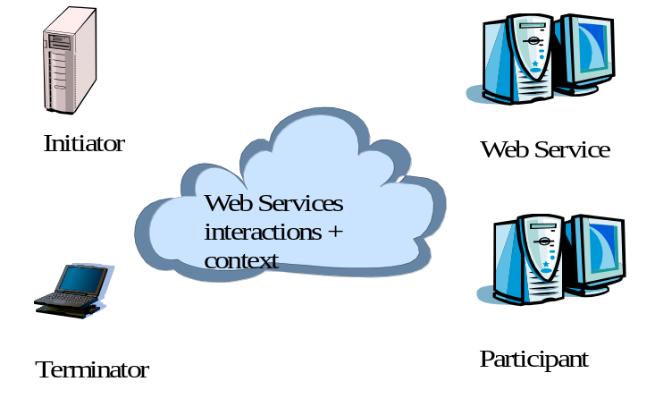
Figure 1: Web Services transaction actors.
For example, an on-line bookshop may well reserve books for an individual for a specific period of time, but if the individual does not purchase the books within that time period they will be “put back onto the shelf” for others to purchase; to do otherwise could result in the shop never selling a single book. Furthermore, because it is not possible for anyone to have an infinite supply of stock, some examples of on-line shops may appear to users to reserve items for them, but in fact if other users want to purchase them first they may well be allowed to (i.e., the same book may be “reserved” for multiple users concurrently); a user may subsequently find that the item is no longer available, or may have to be ordered in specially for them. If these example applications were modelled using atomic transactions, then the reservation process would require the book to be locked for the duration of the atomic transaction, and hence it would have to be available, and could not be acquired by (sold to) another user. When the atomic transaction commits, the book will be removed from stock, and mailed to the user. However, if a failure occurs during the commitment protocol, the book may remain locked for an indeterminate amount of time (or until manual intervention occurs).

When ACID is too strong
It has long been realised that ACID transactions by themselves are not adequate for structuring long-lived applications. To ensure atomicity between multiple participants, a multi-phase (typically two) consensus mechanism is required, as illustrated in Figure 2: during the first (preparation) phase, an individual participant must make durable any state changes that occurred during the scope of the atomic transaction, such that these changes can either be rolled back (undone) or committed later once consensus to the transaction outcome has been determined amongst all participants, i.e., any original state must not be lost at this point as the atomic transaction could still roll back. Assuming no failures occurred during the first phase (in which case all participants will be forced to undo their changes), in the second (commitment) phase participants may “overwrite” the original state with the state made durable during the first phase.
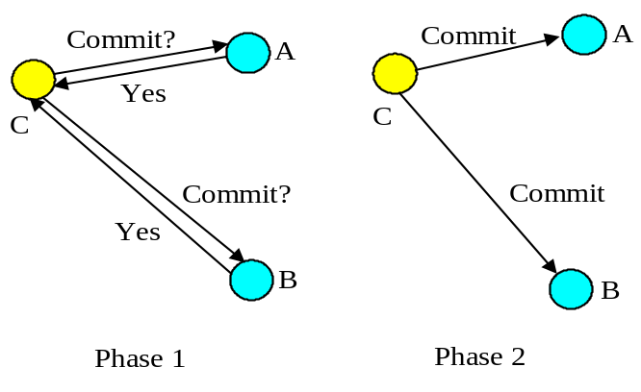
Figure 2: Two-phase commit protocol.
In order to guarantee consensus, two-phase commit is necessarily a blocking protocol: after returning the phase 1 response, each participant which returned a commit response must remain blocked until it has received the coordinator’s phase 2 message telling it what to do. Until they receive this message, any resources used by the participant are unavailable for use by other atomic transactions, since to do so may result in non-ACID behaviour. If the coordinator fails before delivery of the second phase message these resources remain blocked until it recovers. In addition, if a participant fails after phase 1, but before the coordinator can deliver its final commit decision, the atomic transaction cannot be completed until the participant recovers: all participants must see both phases of the commit protocol in order to guarantee ACID semantics. There is no implied time limit between a coordinator sending the first phase message of the commit protocol and it sending the second, commit phase message; there could be seconds or hours between them.
Therefore, structuring certain activities from long-running atomic transactions can reduce the amount of concurrency within an application or (in the event of failures) require work to be performed again. For example, there are certain classes of application where it is known that resources acquired within an atomic transaction can be released “early”, rather than having to wait until the atomic transaction terminates; in the event of the atomic transaction rolling back, however, certain compensation activities may be necessary to restore the system to a consistent state. Such compensation activities (which may perform forward or backward recovery) will typically be application specific, may not be necessary at all, or may be more efficiently dealt with by the application.
For example long-running activities can be structured as many independent, short-duration top-level atomic transactions, to form a “logical” long-running transaction. This structuring allows an activity to acquire and use resources for only the required duration of this long-running activity. This is illustrated in Figure 2, where an application activity (shown by the dotted ellipse) has been split into many different, coordinated, short-duration top-level atomic transactions. Assume that the application activity is concerned with booking a taxi (t1), reserving a table at a restaurant (t2), reserving a seat at the theatre (t3), and then booking a room at a hotel (t4), and so on. If all of these operations were performed as a single atomic transaction then resources acquired during t1 would not be released until the top-level atomic transaction has terminated. If subsequent activities t2, t3 etc. do not require those resources, then they will be needlessly unavailable to other clients.
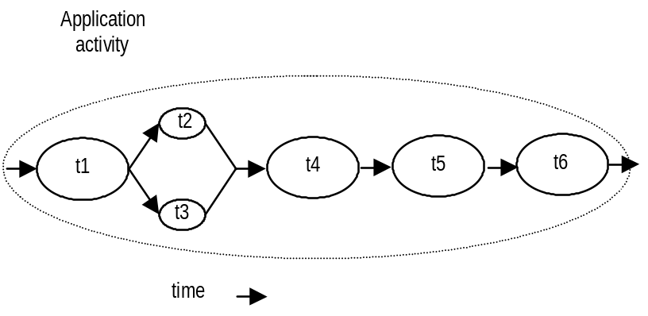
Figure 3: An example of a logical long-running “transaction”, without failure.
However, if failures and concurrent access occur during the lifetime of these individual transactional activities then the behaviour of the entire “logical long-running transaction” may not possess ACID properties. Therefore, some form of (application specific) compensation may be required to attempt to return the state of the system to consistency. For example, let us assume that t4 aborts. Further assume that the application can continue to make forward progress, but in order to do so must now undo some state changes made prior to the start of t4 (by t1, t2 or t3). Therefore, new activities are started; tc1 which is a compensation activity that will attempt to undo state changes performed, by say t2, and t3 which will continue the application once tc1 has completed. tc5’ and tc6’ are new activities that continue after compensation, e.g., since it was not possible to reserve the theatre, restaurant and hotel, it is decided to book tickets at the cinema. Obviously other forms of composition are possible.
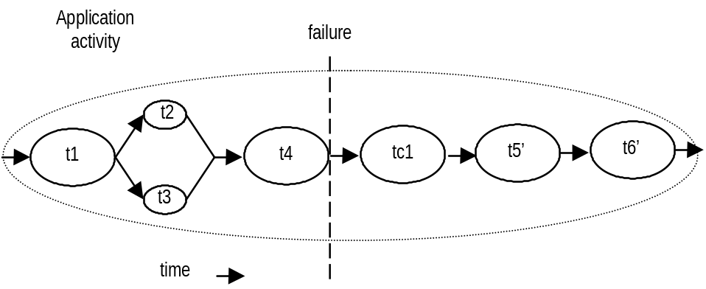
Figure 4: An example of a logical long-running “transaction”, with failure.
Other extended transaction models offer more natural support for additional application requirements. For example, consider the situation shown in Error: Reference source not found, where a user is booking a holiday, has provisionally reserved a flight ticket and taxi to the airport and is now looking for travel insurance. The first consensus group holds Flights and Taxi, since neither of these can occur independently. The user may then decide to visit multiple insurance sites (called A and B, in this example), and as he goes may reserve the quotes he likes. So, for example, A may quote $50, which is just within budget, but the user may want to try B just in case he can find a cheaper price, and without losing the initial quote. If the quote from B is less than that from A, the user may cancel A, while confirming both the flights and the insurance from B. Each insurance site may therefore occur within its own consensus group.
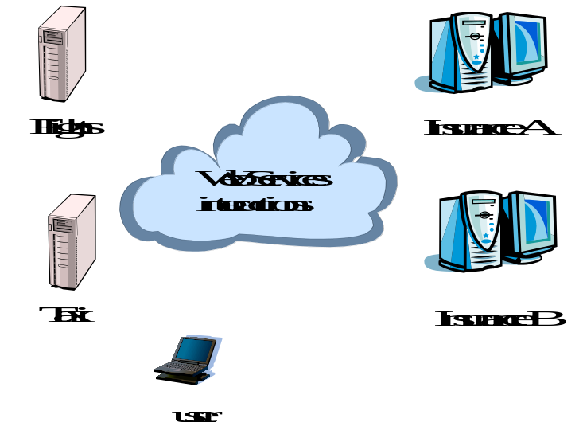
Figure 5: Flight booking.

Existing techniques
Much research on structuring applications out of transactions has been influenced by the ideas of spheres of control [5]. There are several ways in which some or all of the application requirements outlined above could be met [6][7][8][9][10]. We shall briefly describe three, (these are meant as examples only, and submitters need not suggest implementations for them):
- Independent top-level transactions: with this mechanism it is possible to invoke a top-level transaction from within another transaction [6][11]. If the invoking transaction rolls back, this does not lead to the automatic rollback of the invoked transaction, which can commit or rollback independently of its invoker, and hence release resources it acquires. Such transactions could be invoked either synchronously or asynchronously. In the event that the invoking transaction rolls back and compensation is required, compensating transactions may be invoked automatically by the transaction system or dealt with by the application.
- Glued transactions: long-running top-level transactions can be structured as many independent, short-duration top-level transactions, to form a “logical” long-running transaction; the duration between the end of one transaction and the beginning of another is not perceivable, and selective resources can be atomically passed from one transaction to the next [7]. This structuring allows an activity to acquire and use resources for only the required duration of this long-running transactional activity. In the event of failures, to obtain transactional semantics for the entire long-running transaction may require compensation transactions which can perform forward or backward recovery.
- Transactional workflows: a transactional workflow system can be used to provide scripting facilities for expressing the composition of an activity (a business process) out of other activities (which could be transactional), with specific compensation activities [8].
- Business transaction protocol: the OASIS Business Transaction Protocol [ref] introduced the notion of an open-top two-phase termination protocol. Work is conducted within the scope of atoms, which are similar to atomic transactions and have the same all-or-nothing guarantees. However, the outcome of atoms are controlled by cohesions which allow their selective confirmation or cancellation by explicitly driving the two-phase protocol over a period of hours, days etc.
Several industrial transaction systems already exist which support at least one of the above mentioned techniques, although typically not in a Web Services environment. Experiences suggest that different applications and services will require different transaction models. Therefore, although few of the extended transaction models have made it into the world of Web Services currently, it is likely that more will eventually.

Overall aim
Interestingly, from a user’s (client/service) point of view the differences in how these transaction protocols are coordinated and controlled are minimal: the user starts the transactional activity, communicates with services propagating information about the transaction (the context), and terminates the transaction. Most differences occur between the transaction controller (e.g., the coordinator) and its enlisted participants. For example, does it use a two-phase or three-phase termination protocol?
As a result, this specification aims to provide an interface to these different transaction protocols that allows different implementations to be plugged in. If necessary the user can introspect the underlying implementation to determine specific attributes and properties, but we believe that typically this will not be necessary. In addition, if specific models require enhanced interfaces in order to operate, these can be obtained in a structured and well defined manner.
Importantly, the interfaces we provide will not be solely concerned with the front-end user. Specifically, the interfaces can be broken down into the following categories:
- The front-end user (client).
- The service.
- The participant.
- The transaction controller (e.g., coordinator).
Although some implementations of these models may be in Java, others are not. This specification does not provide a means whereby these implementations can be provided to Web Services and their users via SOAP and XML since it is assumed that this has been done elsewhere in other specifications. It is not meant to place additional requirements on existing implementations (e.g., BTP) and is intended to allow such systems to be relatively easily plugged into the architecture.
In addition, the appendices of this specification contain protocol specific information for Java Web Services transaction implementations that do not occur in other specifications. For example, a definition of how components of the JTA/JTS specifications may be incorporated into Web Services, allowing the implementation of ACID Web transactions and services.
Importantly, JAXTX provides higher level abstractions for Java programmers to utilise these existing and future implementations.

JAXTX architecture
The JAXTX architecture can best be described with reference to Figure 6.
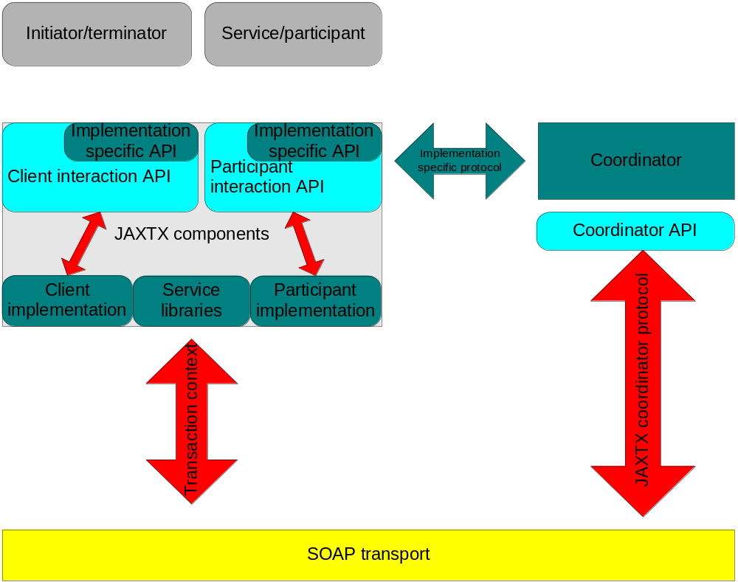
Figure 6: JAXTX architecture.
- The coordinator is responsible for informing enlisted participants about whether they should accept (e.g., commit) or reject (e.g., roll back) the work done within the scope of a given transaction. For example, whether to purchase the (provisionally reserved) flight tickets for the user or whether to release them. The atom is essentially the controller of a consensus grouping.
- The initiator of the transaction communicates with a coordinator and asks it to start a new transaction. The transaction governs the consensus group described previously. Once created, information about the transaction (the context) can be propagated to web services in order for them to associate their work with it, i.e., work is conducted within the scope of a transaction.
- The terminator of the transaction. This will typically be the same entity as the initiator, but need not be, e.g., a long running stock purchase transaction may be started by the company that requires the stock, and finished by the company that delivers it.
- The Web Service, e.g., the taxi booking service. Whenever the initiator contacts a service whose work it wishes to be under the control of a transaction, JAXTX components ensure that it flows the context (information about the transaction) to that service. The service can then use this information to enlist a participant with the transaction.
- Each participant supports a termination protocol specific to the transaction model implemented by the coordinator (e.g., two-phase or three-phase). In addition, the work that a participant performs when instructed by the coordinator that its transaction is terminating is dependant on the participant (e.g., reserve the theatre ticket during the preparatory commit phase). The participant will then return an indication of whether or not it succeeded. However, unlike in traditional ACID transactions, the participant does not have to guarantee that it can remain in this prepared state; it may indicate that it can only do so for a specified period of time, and also indicate what action it will take (confirm or undo) if it has not been told how to finish before this period elapses. The entity that enrolls a participant in a specific transaction may be the Web Service, the participant itself, or some other entity. Note, a web service may play the role of a participant.
- The context and coordinator-to-participant protocol are implementation specific and have a format that is typically specified in other protocol documents, e.g., BTP [ref]. It is not the domain of this specification to impinge on these protocols and require changes to them. As such, it is assumed that these will be specified elsewhere and relevant JAXTX component implementations will conform to them.
Although many protocols have similar client-side interfaces (e.g., beginning and ending a transaction), it is the coordinator-to-participant interactions that are typically the most protocol dependant. This specification does not attempt to provide a means whereby such protocol differences can be supported by a single implementation, since this is the domain of other specifications [jsr95][omgas]. What it does do, however, is provide a basic coordinator-to-participant protocol that must be extended in an implementation specific manner. This allows existing transaction systems to be plugged into a JAXTX implementation unmodified: all that is required is a standardisation of the specific coordinator-to-participant interface, which will already have been agreed upon by the designers of the transaction system in question, and for which JAXTX does provide some support.

Components, implementations and applications
Figure 7 illustrates a typical configuration for a transactional Web Services application. There is obviously a requirement for an application service (e.g., a flight booking service), and the client that will use it (their interactions are shown in red). In addition, there must be some transaction coordination service responsible for ensuring that the work performed by the client occurs in some manner consistent with the underlying transaction model (e.g., that it either happens or does not despite failures). Collaboration between the coordinator service and some application service specific participant will also be required.
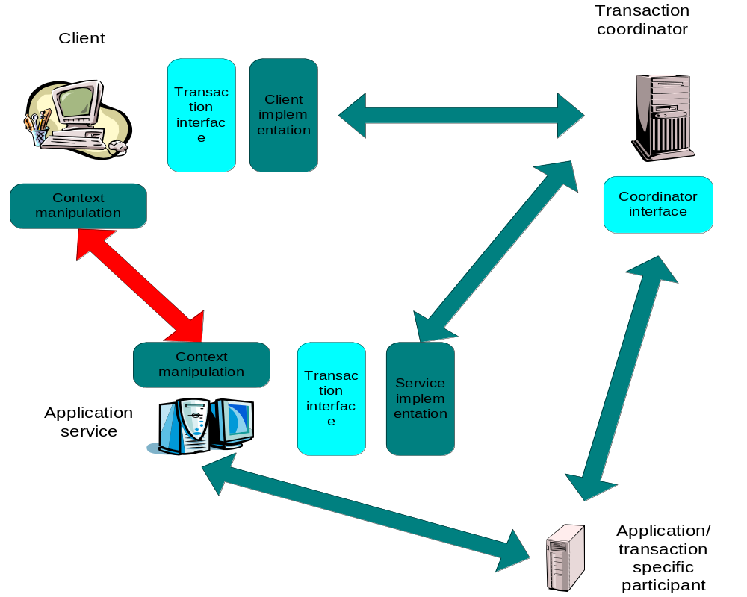
Figure 7: Applications and implementation components.
It is envisioned that in most situations the dark blue areas are already provided by existing standards and systems. For example, the OASIS Business Transactions Protocol defines precisely how the transaction context appears in transmitted XML documents, how coordinator specific messages are formatted, how participants behave under certain failure circumstances etc. However, the interfaces to these components will typically be defined in their specifications or may even be proprietary. JAXTX provides a uniform set of interfaces that are intended to indirect to the underlying implementations.
The generic interfaces, shown in light blue, are intended to allow users to concentrate on the functional aspects of interacting with different services, whereas the implementation specific interfaces will be used by service and participant implementers. Such implementers already have requirements and (possibly) programming interfaces placed on them by the protocols that they are using and all that JAXTX does is provide an extensible way in which these can be plugged into a JAXTX implementation. These implementations communicate with their underlying protocol specific equivalents, providing mappings to and from the generic interface and its types where appropriate. However, as will be shown in the next section, it is possible for users to obtain direct access to a more appropriate, system specific interface if necessary.

Elements of JAXTX

Features
The features provided by JAXTX to support the plugging of different transaction implementations within the Web Services architecture are described in this section.

Generic client interface
Despite the variety of extended transaction models, the interfaces that most clients use to interact with them are very similar. These typically involve: starting and ending a transaction (possibly ending in multiple ways, e.g., commit or roll back), and associating/disassociating a transaction with/from the current thread of control. The UserTransaction is responsible for encapsulating this common functionality within a single interface. An implementation of the UserTransaction is also responsible for obtaining a reference to a conformant coordinator service and then binding to it. This may happen when the UserTransaction is first obtained by the client or when it is first used. The UserTransaction then interacts with the coordinator service when instructed to by the client using whatever SOAP/XML protocol is required by the service implementation it wraps.
In addition, the client requires some means by which the transaction context may be associated with any outgoing service invocation. As with the rest of the UserTransaction implementation, the format of the context, where it occurs within an XML invocation document etc. will be specified in the appropriate implementation specification. The implementation of the UserTransaction is required to encapsulate this context manipulation in a transparent manner to the client, such that, as far as the client is concerned, the context flows implicitly with all relevant invocations.
As mentioned in Section 3.1, the client-side implementation of this interface is typically expected to interact with a service specific implementation that has been defined elsewhere. However, for those cases where no such external definition exist, this specification contains sufficient information for such a model to be implemented.

Specific client interfaces
Some extended transaction implementations may require extensions to the general UserTransaction interfaces. For example, in the OASIS BTP there is scope for the client application to drive the two phase completion protocol explicitly, rather than leaving it to the coordinator as typically happens in other transaction models. Thus, there is a requirement for more than simply telling the transaction coordinator to end.
In order to determine the properties of the underlying implementation, the UserTransaction configuration and properties are available in the form of a org.w3c.dom.Document. If the client requires access to protocol specific interfaces that the implementation supports, then it can safely cast the underlying implementation to obtain access to the extensions.

Generic coordinator interface
As with the client, there are some similarities from a service point of view as to how a service or participant interacts with a transaction coordinator. However, this generality is on a smaller scale than for the front-end client, typically involving only registering and un-registering participants. These methods are provided by the Coordinator interface, and as with the UserTransaction, services are expected to safely cast the basic interface to a more protocol specific version if necessary. All configuration information is made available via an XML document, an instance of the org.w3c.dom.Document.
As with the UserTransaction, Coordinator implementations are expected to communicate with protocol specific counterparts. It is possible that a single coordinator may be able to drive multiple types of participant (e.g., two-phase or three-phase). However, a given service may try to enlist the wrong type of participant, and as such the coordinator is responsible for returning an indication of why the registration has failed. The type of participant(s) that a coordinator implementation supports may be made available via its XML configuration document.

Participant interface
The coordinator-to-participant protocol is extremely transaction model specific and leaves little room for generality. As such, the Participant interface is essentially a marker/handle for the more specific participant implementation. The Coordinator is expected to determine that the Participant is of a type that it can work with (through the available XML configuration information) and then safely narrow the Participant to the specific type.
If the types of participant implementations a coordinator supports are not made available through its XML configuration document, or the entity that enrols the service/participant has not determined that the coordinator supports the participant, then the coordinator is required to fail the enrolment and indicate the reason why.

Service interface
As shown in Figure 7, just as with the client, the transactional Web Service will require context manipulation functionality, typically provided by the container that the service resides within. As with the client, this context manipulation is expected to be transparent to the service. Therefore, services that do not start or terminate transactions, and hence would use UserTransaction implementations, are not expected to have access to transaction specific code. However, in order that implementations of such functionality may be categorized within JAXTX, they can derive from the Service interface and be made available via JNDI, for example.

Context management

JAXTX packages

Issues to be resolved
Download client implementation and context manipulator. Service downloads participant binding and context manipulator. How to download both in one go, since they are related?

References

